**PROJECT – 4**

**PROJECT NAME :**  **TIC TAC TOE GAME**

**NAME OF THE STUDENT : Y.KEERTHANA REDDY**

**DATE OF THE PROJECT : 7-08-2023**

**PROJECT SUMMARY :**

The objective of this tic-tac-toe game java project is to build a tic-tac-toe game so anyone can play it without wasting paper. The Tic-Tac-Toe game is also called the X and O game. The player who succeeds in placing their marks in a diagonal, horizontal, or vertical row is the winner.

The game’s rules are straightforward and well-known.

Two players, X and O, will play this game by alternately marking the squares in a 3X3 grid.

Only one symbol may be placed by each player at every turn, after which the turn is passed to the other player.

Game approach:

Wins: Each player attempts to arrange three symbols in three adjacent cells that are either horizontally, vertically, or diagonally spaced. The winner is the one who accomplishes this alignment first. The second player attempts to obstruct Player 1’s alignment by inserting his symbols between Player 1’s symbols.

Lose: You lose if your rival achieves the necessary symbol alignment faster.

**INPUT :**

**package SourceCode;**

**import javax.swing.*;**

**import java.awt.*;**

**import java.awt.event.*;**

**import java.util.Random;**

**public class TicTacToeGame implements ActionListener {**

**Random random=new Random();**

**JFrame frame=new JFrame();**

**JButton buttons[]=new JButton[9];**

**JLabel textfield=new JLabel();**

**JPanel Heading_Panel=new JPanel();**

**JPanel Button_Panel=new JPanel();**

**boolean player1_turn=true;**

**TicTacToeGame(){**

**//Frame**

**frame.setVisible(true);**

**frame.setSize(800,800);**

**frame.getContentPane().setBackground(new Color(50,50,50));**

**frame.setLayout(new BorderLayout());**

**//Heading**

**textfield.setFont(new Font("Ink Free",Font.BOLD,40));**

**textfield.setBackground(new Color(25,25,25));**

**textfield.setForeground(new Color(25,255,0));**

**textfield.setHorizontalAlignment(JLabel.CENTER);**

**textfield. setText("TIC-TAC GAME");**

**textfield.setOpaque(true);**

**//Heading panel**

**Heading_Panel.setLayout(new BorderLayout());**

**Heading_Panel.setBounds(0,0,800,100);**

**Heading_Panel.add(textfield);**

**frame.add(Heading_Panel,BorderLayout.NORTH);**

**//Button pannel**

**Button_Panel.setLayout(new GridLayout(3,3));**

**Button_Panel.setBackground(new Color(150,150,150));**

**for(int i=0;i<9;i++){**

**buttons[i]=new JButton();**

**buttons[i].addActionListener(this);**

**buttons[i].setFont(new Font("MV Boli",Font.BOLD,100));**

**Button_Panel.add(buttons[i]);**

**}**

**frame.add(Button_Panel);**

**firstTurn();**

**}**

**public void actionPerformed(ActionEvent e){**

**for (int i=0;i<9;i++){**

**if (e.getSource()==buttons[i]){**

**if(player1_turn){ //true X turn**

**if (buttons[i].getText()==""){**

**buttons[i].setForeground(new Color(255,0,0));**

**buttons[i].setText("X");**

**player1_turn=false;**

**textfield.setText("O TURN");**

**check(); //calling check function**

**}**

**}**

**else{ //O turn false**

**if (buttons[i].getText()==""){**

**buttons[i].setForeground(new Color(0,0,255));**

**buttons[i].setText("O");**

**player1_turn=true;**

**textfield.setText("X TURN");**

**check(); //calling check function**

**}**

**}**

**}**

**}**

**}**

**public void check() {**

**//X Win Conditions**

**if(buttons[0].getText()=="X" && buttons[1].getText()=="X" && buttons[2].getText()=="X"){**

**XWin(0,1,2); // calling XWin Function**

**}**

**if(buttons[3].getText()=="X" && buttons[4].getText()=="X" && buttons[5].getText()=="X"){**

**XWin(3,4,5); // calling XWin Function**

**}**

**if(buttons[6].getText()=="X" && buttons[7].getText()=="X" && buttons[8].getText()=="X"){**

**XWin(6,7,8); // calling XWin Function**

**}**

**if(buttons[0].getText()=="X" && buttons[3].getText()=="X" && buttons[6].getText()=="X"){**

**XWin(0,3,6); // calling XWin Function**

**}**

**if(buttons[1].getText()=="X" && buttons[4].getText()=="X" && buttons[7].getText()=="X"){**

**XWin(1,4,7); // calling XWin Function**

**}**

**if(buttons[2].getText()=="X" && buttons[5].getText()=="X" && buttons[8].getText()=="X"){**

**XWin(2,5,8); // calling XWin Function**

**}**

**if(buttons[0].getText()=="X" && buttons[4].getText()=="X" && buttons[8].getText()=="X"){**

**XWin(0,4,8); // calling XWin Function**

**}**

**if(buttons[2].getText()=="X" && buttons[4].getText()=="X" && buttons[6].getText()=="X"){**

**XWin(2,4,6); // calling XWin Function**

**}**

**// O Win Conditions**

**if(buttons[0].getText()=="O" && buttons[1].getText()=="O" && buttons[2].getText()=="O"){**

**OWin(0,1,2); // calling OWin Function**

**}**

**if(buttons[3].getText()=="O" && buttons[4].getText()=="O" && buttons[5].getText()=="O"){**

**OWin(3,4,5); // calling OWin Function**

**}**

**if(buttons[6].getText()=="O" && buttons[7].getText()=="O" && buttons[8].getText()=="O"){**

**OWin(6,7,8); // calling OWin Function**

**}**

**if(buttons[0].getText()=="O" && buttons[3].getText()=="O" && buttons[6].getText()=="O"){**

**OWin(0,3,6); // calling OWin Function**

**}**

**if(buttons[1].getText()=="O" && buttons[4].getText()=="O" && buttons[7].getText()=="O"){**

**OWin(1,4,7); // calling OWin Function**

**}**

**if(buttons[2].getText()=="O" && buttons[5].getText()=="O" && buttons[8].getText()=="O"){**

**OWin(2,5,8); // calling OWin Function**

**}**

**if(buttons[0].getText()=="O" && buttons[4].getText()=="O" && buttons[8].getText()=="O"){**

**OWin(0,4,8); // calling OWin Function**

**}**

**if(buttons[2].getText()=="O" && buttons[4].getText()=="O" && buttons[6].getText()=="O"){**

**OWin(2,4,6); // calling OWin Function**

**}**

**}**

**private void XWin(int a, int b, int c) {**

**buttons[a].setBackground(Color.GREEN);**

**buttons[b].setBackground(Color.GREEN);**

**buttons[c].setBackground(Color.GREEN);**

**for(int i=0;i<9;i++){**

**buttons[i].setEnabled(false); //Disable the buttons after win**

**}**

**textfield.setText("!! Congratulations, X Wins");**

**}**

**public void OWin(int a, int b, int c){**

**buttons[a].setBackground(Color.GREEN);**

**buttons[b].setBackground(Color.GREEN);**

**buttons[c].setBackground(Color.GREEN);**

**for(int i=0;i<9;i++){**

**buttons[i].setEnabled(false); //Disable the buttons after win**

**}**

**textfield.setText("!! Congratulations, O Wins");**

**}**

**public void firstTurn(){**

**try {**

**Thread.sleep(2000);**

**} catch(Exception e){**

**e.printStackTrace();**

**}**

**if(random.nextInt(2)==0){**

**player1_turn=true;**

**textfield.setText("X TURN");**

**}**

**else{**

**textfield.setText("O TURN");**

**}**

**}**

**public static void main(String[] args){**

**// TODO Auto-generated method stub**

**new TicTacToeGame();**

**}**

**}**

**OUTPUT:**

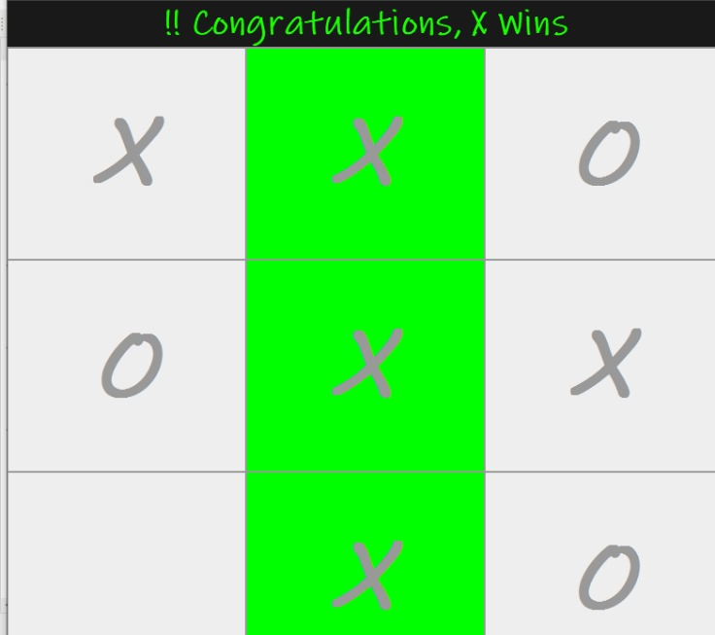

Project By Y.Keerthana Reddy.